Vision Guided Robotic Refueling of Haul Trucks

Phase Two – Pose system implementation

Abstract
Background: Mine Energy Solutions (MES) is a Brisbane based small to medium enterprise (SME) developing a refuelling system for mine dump trucks. The system is based on high density compressed natural gas (HDCNG™). The HDCNG™ is stored in cylinders that make up a “Cassette”. These cassettes are filled at a compression station and it is proposed that they are swapped on and off trucks using a robot manipulator that travels on a linear translation table. Each cassette weighs approximately 700 kg. In the concept of operation, the truck drives into the refuelling station, parks, and robot manipulators replenish both the HDCNG™ and diesel fuel. The position and orientation of the HDCNG™ cassette holder and a diesel fuel-filler neck must be established to required tolerances in order that the robot can correctly position. These will vary as each truck arrives to be refuelled. Phase One of the project developed a candidate solution method. Phase Two implements that method.

The gap: The overall system will leverage off-the-shelf technologies as far as possible. However, MES has identified two gaps that cannot be bridged by existing technology: (i) determining the position and orientation (pose) of the cassette holder that is located on the truck body; and (ii) determining the pose of the diesel fuel-filler neck.

The objective: To develop the capability (algorithms, software and hardware) to allow the required pose information to be established on the arrival of each truck at the refuelling station.

The research question: What is required to find the spatial pose of the cassette holders and diesel fuel-filler neck to specified accuracy and reliability?

Major benefit: Accurate and reliable pose information will enable a robot manipulator to autonomously swap out the HDCNG™ cassettes and refill the diesel fuel.

Key risks: The capability to solve this problem does not currently exist. The accuracy and reliability requirements for loading/unloading cassettes are extremely tight. Pose estimation is complex and contains many sources of uncertainty. It is unknown to what level of accuracy the pose can be established from available sensor measurements. The ability to determine pose to the specified reliability and accuracy requirements is uncertain.

Table of Contents
Abstract 1
1. Background 3
2. Solution Implementation 4
2.1. Software requirements and architecture design 4
2.2. SICK 3Vistor-T device level software 4
2.3. Collect data set for algorithm development 4
2.4. Assemble computing hardware 5
2.5. Develop algorithm for loaded cradle pose estimation 5
2.6. Develop algorithm for empty cradle pose estimation 5
3. Solution integration and validation 5
3.1. Implement diagnostic and fault logging capability 6
3.2. Develop registration procedure 6
3.3. Establish communication with supervisory PLC 6
3.4. PES integration with supervisory PLC 6
3.5. Validation of system against system requirements specification 6
4. Knowledge management 6
4.1. Assemble deployment package 6
4.2. Assemble system documentation 7
5. Risks 8
6. Decision to iterate the chosen concept 12
7. Timeline 13
8. Budget 14

Background
Mine Energy Solutions (MES) is a Brisbane based small to medium enterprise (SME) developing a refuelling system for mine dump trucks. The system is based on high density compressed natural gas (HDCNG™). The HDCNG™ is stored in cylinders that make up a “Cassette”. These cassettes are filled at a compression station and it is proposed that they are swapped on and off trucks using a robot manipulator that travels on a linear translation table. Each cassette weighs approximately 700 kg.

In the concept of operation, the truck drives into the refuelling station, parks, and robot manipulators replenish both the HDCNG™ and diesel fuel (Figure 1). The position and orientation of the HDCNG™ cassette cradle and a diesel fuel-filler neck must be established to required tolerances in order that the robot can correctly position. These will vary as each truck arrives to be refuelled.

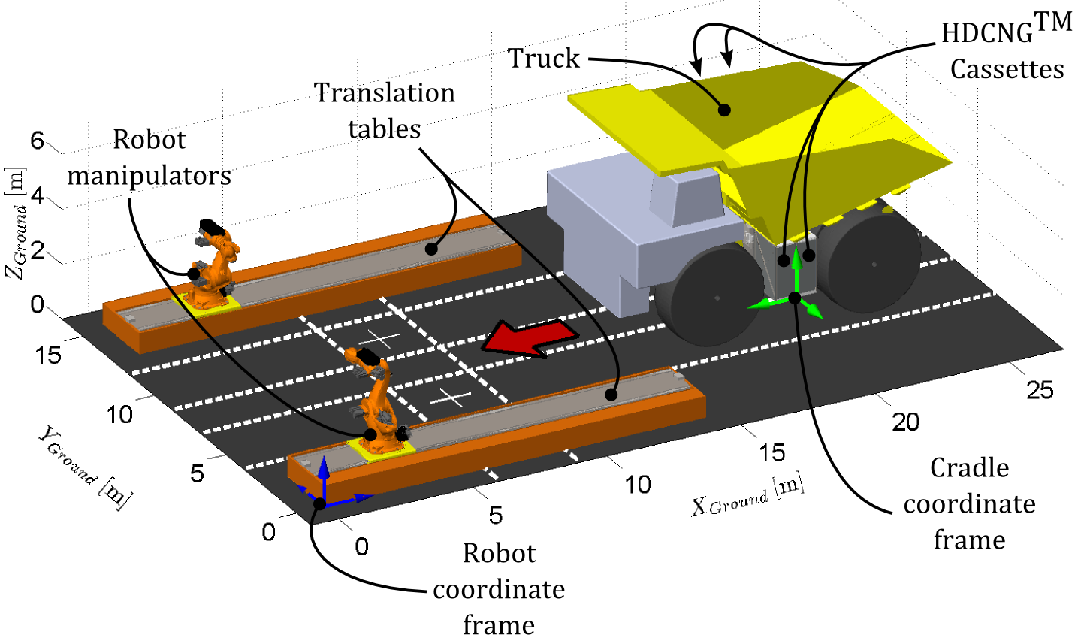
Figure 1:General assembly of the refuelling station and related terminology.

The overall system will leverage off-the-shelf technologies as far as possible. However, MES has identified two gaps that cannot be bridged by existing technology:
- Determining the position and orientation (pose) of the cassette cradle that is located on the truck body; and
- Determining the pose of the diesel fuel-filler neck.

MES has approached the Smart Machine Group in the School of Mechanical and Mining Engineering at The University of Queensland to undertake the necessary research to establish the pose of HDCNG™ cassette and diesel fuel-filler neck. This research will have as its aim, to develop the capability (algorithms, software and hardware) to allow the required pose information to be established on the arrival of each truck at the refuelling station.

This proposal details Phase Two which will seek to implement the preferred candidate solution established during Phase One. The concept to be implemented (Concept C2) seeks to determine the HDCNG™ cassette cradle pose using a statically mounted 3D LiDAR and is described in Phase One’s ideation report, SMG Report MES-02-16.

This phase consists of three parts: i) solution implementation; ii) solution integration and validation; and iii) knowledge management. The outcome of Phase Two will be an implementation of the Robotic Refuelling Pose Estimation System (RRPES) that meets the Stakeholder Requirements Specification developed in Phase one. A deployment package and system documentation will also be delivered at handover.

Solution Implementation
The following six tasks relate to the design and implementation of the pose estimation system. A decision will be made at the end of these tasks as to whether the design requires iteration, if so, a phase three proposal will be produced that details the required work plan.

Software requirements and architecture design
This task will develop a software architecture for the Robotic Refuelling Pose Estimation System (RRPES) and present it as UML diagrams.

Success measure: Documented requirements and design for RRPES. Identification of all communication requirements.

SICK 3Vistor-T device level software
The aim of this task is to procure a Sick 3Vistor-T scanner, develop software drivers to acquire data from it, and verify that these components function.

Success measure: Utilities provide resource manager interface for data acquisition, and sensor configuration.

Collect data set for algorithm development
The aim of this task is to collect a set of data that can be used to inform development of the PES algorithm. The work will involve installing the SICK 3Vistor-T on a tripod or similar with a cassette/cassette holder in its field of view. It has been discussed that this will be achievable while the truck is being fitted with the MES cassette cradle at the Hastings facility in Archerfield. Scans will be taken from several locations to capture variations in different sensor placements and truck positions. A ground truth scan will be made using an independent sensor, e.g. Faro Focus^{3D}.

Success measure: Fit-for-purpose data set collected.

Assemble computing hardware
A computer is required with that is capable of performing the cradle pose estimation algorithm within five seconds. This task is to determine the required specifications, purchase and build the computer. The computer will use a Linux based operating system.

Success measure: A fit-for-purpose computer is assembled.

Develop algorithm for loaded cradle pose estimation
This task will take the collected data set and develop and evaluate pose estimation algorithms for determining loaded cradle pose.

The purpose of the task is twofold: 1) develop software to perform the pose estimation; and 2) establish that it is possible to meet the stakeholder requirements on accuracy and timeliness, and thereby develop confidence that the technology can work. If it is apparent that the methods will not succeed, this phase of the work will terminate at this task and an alternative strategy will be developed.

Success measure: Able to provide a best estimate of loaded cradle pose and establish if the candidate method is likely to meet accuracy and timeliness requirements. If negative, alternative candidate methods to be explored, having developed work breakdowns for those.

Develop algorithm for empty cradle pose estimation
This task will take the collected data set and develop and evaluate pose estimation algorithms for determining empty cradle pose. It is anticipated that the developed algorithms will be variations of those developed for determining the pose of loaded cradles.

The purpose of the task is twofold: 1) develop software codes to perform the pose estimation; and 2) establish that it is possible to meet the stakeholder requirements on accuracy and timeliness, and thereby develop confidence that the technology can work. If it is apparent that the methods will not succeed, this phase of the work will terminate at this task and an alternative strategy will be developed.

Success measure: Able to provide a best estimate of empty cradle pose and establish if the candidate method is likely to meet accuracy and timeliness requirements. If negative, alternative candidate methods to be explored, having developed work breakdowns for those.

Solution integration and validation
The following five tasks relate to the deployment of the pose estimation system and validation of its behaviour.

Implement diagnostic and fault logging capability
The purpose of this task is to meet various requirements identified in the Stakeholder Requirements Specification associated with diagnostics and fault logging.

Success measure: A fit-for-purpose fault logging and diagnostic interface is operational with PES.

Develop registration procedure
The purpose of this task are twofold: 1) design, fabricate and install a mount for the SICK 3Vistor-T; and 2) manually register the mount to the robot frame, and develop a procedure for automatically performing sensor registration.

Success measure: A fit-for-purpose mount is installed and registered. It is verified that the mount can be automatically registered to the required precision in adjusted locations.

Establish communication with supervisory PLC
This task seeks to integrate existing software libraries (free or commercial) for PLC Ethernet-IP communication with the RRPES software architecture.

Success measure: The outgoing RRPES communications can be made over PLC Ethernet-IP protocol.

PES integration with supervisory PLC
This task will integrate the RRPES with the supervisory controller.

Success measure: Pose estimates or faults are returned from the RRPES when a pose request is received from the supervisory controller.

Validation of system against system requirements specification
This task seeks to validate the complete RRPES against the success measures of the Stakeholder Requirements Specification.

Success measure: The RRPES passes all validation tests in the SRS.

Knowledge management
The following two tasks relate to deployment and documentation activities required at handover.

Assemble deployment package
A deployable package is required with instruction. This task seeks to assemble this package.

Success measure: A deployment package with instruction can be deployed by MES engineers.

Assemble system documentation
This task seeks to develop a final project report with complete RRPES documentation. The documentation will include a detailed description of the pose estimation algorithm allowing iterative changes to be implemented by MES engineers (e.g. instruction for scalability with different truck/cradle geometries).

Success measure: System documentation is handed over that thoroughly details the RRPES such that MES engineers may make continue to develop the overall refuelling system.

Risks
The research risk assessment matrix (Figure 2) is used in evaluation of research risks at each task.

SMG RISK ASSESSMENT MATRIX |  | Hazard Effect / Consequence
Loss Type |  | 1  Insignificant | 2  Minor | 3  Moderate | 4  Major | 5  Catastrophic
Harm to People |  | Slight injury or health effects – first aid/ minor medical treatment level | Minor injury or health effects – restricted work or minor lost workday case | Major injury or health effects – major lost workday case/ permanent disability | Permanent total disabilities, single fatality | Multiple fatalities
Environmental Impact |  | Environmental nuisance | Material environmental harm | Serious environmental harm | Major environmental harm | Extreme environmental harm
Asset Damage & Other Consequential Losses |  | Slight damage <$5000. No disruption to operation | Minor damage $5,000 to $50,000. Brief disruption to operation | Local damage $50,000 to $500,000. Partial shutdown | Major damage $500,000 to $1M. Partial loss of operation | Extreme damage > $1M. Substantial or total loss of operation
Project execution |  | Slight impact – no concern | Limited impact – some concern | Considerable impact | Technical or project issues impact outcomes | Project unable to deliver
Likelihood | Likelihood Examples  (use only as a guide for evaluation of uncontrolled hazards) | Risk Rating
A  (Almost certain) | Likely that the unwanted event could occur several times per year in mining industry | 15 (M) | 10 (H) | 6 (H) | 2 (Ex) | 1 (Ex)
B  (Likely) | Likely that the unwanted event could occur several times per year in mining industry | 19 (M) | 14 (M) | 9 (H) | 4 (Ex) | 3 (Ex)
C  (Possible) | The unwanted event could well have occurred in the mining industry at some time in the past 10 years | 22 (L) | 18 (M) | 13 (H) | 8 (H) | 5 (Ex)
D  (Unlikely) | The unwanted event has happened in the mining industry at some time; or could happen in 100 years | 24 (L) | 21 (L) | 17 (M) | 12 (H) | 7 (H)
E  (Rare) | The unwanted event has never been known to occur in the mining industry; or is highly unlikely that it could ever occur | 25 (L) | 23 (L) | 20 (M) | 16 (M) | 11 (H)
Risk Rating | Risk Level – Priority | SMG Risk Score Statement  (Ref: QLD Electrical Safety Code of Practice)
1 – 5 | (Ex) – Extreme | ACT NOW – Urgent – Do Something about the risks immediately – May require a minimum of 2 hard control barriers and 2 soft controls.
6 – 13 | (H) – High | Highest management decision is required urgently – may require the implementation of 2 hard control barriers and 2 soft controls.
14 – 20 | (M) – Medium | Follow management instructions – May require 1 hard control and 2 soft controls.
21 – 25 | (L) – Low | OK for now. Record, monitor and review if any situation / equipment / people / materials / work processes or procedures change.
Figure 2 Risk assessment matrix

There are 3 types of risk detailed in this proposal: i) Project Risks, which may impede the success of the project; ii) Technical Risks, that are seen to challenge functionality of the system; and iii) Activity Risks, which emanate from hazards that may result in injury or equipment damage. Details are shown in Table 1, Table 2, and Table 3.

Table 1 Project Risks
Project Risks
What are the main steps of the task or activity? | What is the hazard? | Initial Risk |  |  | Current Control Measures and Actions Required | Risk after controls |  |  | People responsible
What are the main steps of the task or activity? | What is the hazard? | L | C | R | Current Control Measures and Actions Required | L | C | R | People responsible
General project work | Project runs over time | B | 3 | 9H | Time management against project tasks using JIRA issue tracking software. | D | 3 | 17M | Tyson, Kevin, Ross
General project work | Project runs over budget | D | 3 | 17M | Unlikely to go over budget. Limited hardware/fabrication costs. Human resources managed also managed in JIRA. | D | 3 | 17M | Tyson, Ross
Ordering SICK 3Vistor-T | The sensor has a longer than expected lead time (1-2 weeks). | C | 2 | 18M | The project is organised to allow other tasks not requiring the SICK sensor to be completed in the interim, e.g. tasks around PLC communication. | C | 1 | 22L | Tyson, Kevin
Fabricating the SICK mount | The lead time for fabrication of parts is longer than expected (1-3 weeks). | C | 2 | 18M | The project is organised to allow other tasks not requiring the sensor mount to be completed in the interim, e.g. Algorithm development and fault detection tasks. | C | 1 | 22L | Tyson, Kevin

Table 2 Technical Risks
Technical Risks
What are the main steps of the task or activity? | What is the hazard? | Initial Risk |  |  | Current Control Measures and Actions Required | Risk after controls |  |  | People responsible
What are the main steps of the task or activity? | What is the hazard? | L | C | R | Current Control Measures and Actions Required | L | C | R | People responsible
Implementing static sensor mount concept | The static sensor mount concept does not meet accuracy and timeliness requirements. | B | 5 | 3Ex | A redesign of the RRPES is required if the accuracy requirement cannot be met reliably (see flow chart in next Section). Validation tests in Task 4.5 will verify pose via independent survey prior to loading/unloading with the robot manipulator. | D | 3 | 17M | Tyson
Sensing with the SICK 3Vistor-T | We have not used this sensor before, it might not be fit-for-purpose. | C | 3 | 13H | The Velodyne HDL-16 sensor will serve as a backup sensor to repeat Task 3.3. | D | 3 | 17M | Tyson
Loading cassettes | There are likely to be oscillatory modes in the robot arm when moving a 700kg mass at large leaver arms. This may prevent the end effector from being placed within 20mm of the estimated pose. | B | 4 | 4Ex | Iterate the mechanical design of the end effector to consider remote centre compliance or use 8th axis translation table to reduce lever arm. | D | 3 | 17M | All
Estimating pose | The solution cannot estimate pose within the 5 second requirement | C | 3 | 13H | There are many ways to reduce computation time, e.g. using reflective tape to reduce measurements, using more expensive GPUs that provide greater parallelizability, or changing estimation algorithm.  Failing this, the five second requirement may need review, a sequencing diagram will shed insight into available estimation time. | D | 3 | 17M | Tyson

Table 3 Workplace Health and Safety Risks
Workplace Health and Safety Risks
What are the main steps of the task or activity? | What is the hazard? | Initial Risk |  |  | Current Control Measures and Actions Required | Risk after controls |  |  | People responsible
What are the main steps of the task or activity? | What is the hazard? | L | C | R | Current Control Measures and Actions Required | L | C | R | People responsible
Working in the robot workspace | The robot may pin/crush personnel | C | 4 | 8H | A laser curtain around the fuel facility will deactivate the robot if personnel enter this space. Tests that involve moving the robot will not be started until all personnel are outside of this perimeter. | E | 4 | 16M | ALL
Commanding the robot to an estimated pose | The robot damages the cassette/cradle | A | 3 | 6H | The pose solution will be checked against a surveyed truth prior to commanding the robot manipulator to load/unload.  Pose solutions will be checked first prior to each verification test. | D | 3 | 17M | Vitor, Tyson
Commanding the robot to an estimated pose | The robot damages a tyre | B | 4 | 4Ex | The truck must be parked in a constrained region, a hard control measure is needed to ensure this, either autonomously via range finder or by visual inspection.  The pose solution is checked against an envelope of feasible pose, for a truck parked correctly. | E | 4 | 16M | Vitor, Tyson
Commanding the robot to an estimated pose | The robot damages itself or the translation table. | C | 3 | 13H | The cradle pose solution is checked to ensure that the robot will be placed in a collision free pose with itself and the track geometry. | E | 3 | 20M | Tyson
Repositioning the cradle | Personnel in the immediate area may be pinned or crushed. | C | 4 | 8H | Take 2 before moving the cradle. Ensure all personnel are aware and free from harm. | E | 4 | 16M | ALL

Decision to iterate the chosen concept
The risk related to “Implementing static sensor mount concept” is rated in the extreme priority, as it has both a high likelihood (B: Likely) and high consequence (5: Catastrophic).

The feasibility of the proposed concept will be known after the solution implementation tasks have been completed. A work breakdown structure and costing will be developed for implementation of concept C4 if the solution appears inadequate (see Rescope 1 and 2).

Solution implementation

3.1 Software requirements and architecture design

3.2 SICK 3Vistor-T device level software

3.3 Collect static mount dataset for algorithm deployment

3.4 Assemble computing hardware

4.3 Establish communication with supervisory PLC

4.4 PES integration with supervisory PLC

Rescope 1
3.5 Develop algorithm for loaded cradle pose estimation

Rescope 2

3.6 Develop algorithm for empty cradle pose estimation
SUCCESS – Continue to system integration
FAIL – Develop proposal for extending implementation to include concept C4 (see SMG Report: MES -02-16).

Solution integration and validation

4.1 Implement diagnostic fault logging capability

4.2 Develop autonomous registration procedure

4.5 Validation of system against SRS

Knowledge management

5.1 Assemble deployment package

5.2 Assemble system documentation

Timeline
The proposed timeline for this phase of the project is as follows:
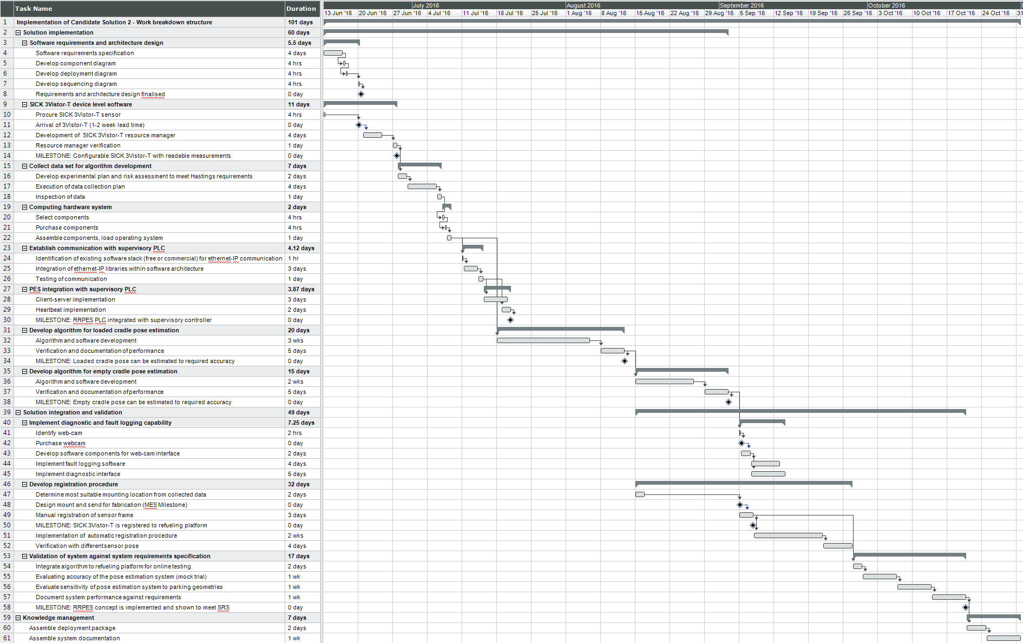
Milestone 2 Payment
Rescope
2
Rescope
1
Milestone 1 Payment
Milestone 3 Payment

Budget
Table 4, Table 5, and Table 6 detail the allocation of human resources to each of the tasks included in the three payment milestones respectively.

Table 4 Milestone 1 Resource Allocation
# | Tasks in Milestone 1 | Duration | Resources allocated
# | Tasks in Milestone 1 | Duration | Phillips | Austin | McAree
3.1 | Software requirements and architecture design
 | Software requirements specification | 4 | 4 | 1 | 1
 | Develop component diagram | 0.5 | 0.5 | 0 | 0
 | Develop deployment diagram | 0.5 | 0.5 | 0 | 0
 | Develop sequencing diagram | 0.5 | 0.5 | 0 | 0
 | MILESTONE: Requirements and architecture design finalised
3.2 | SICK 3Vistor-T device level software
 | Procure SICK 3Vistor-T | 0.5 | 0.5 | 0 | 0
 | Arrival of SICK 3Vistor-T | 0 | 0 | 0 | 0
 | Development of SICK 3Vistor-T resource manager | 4 | 2 | 4 | 0
 | Resource manager verification | 1 | 1 | 0 | 0
 | MILESTONE: Configurable SICK 3Vistor-T with readable measurements
3.3 | Collect data set for algorithm development
 | Develop experimental plan and risk assessment to meet Hastings requirements | 2 | 2 | 1 | 0.5
 | Execution of data collection plan | 4 | 2 | 2 | 0
 | Inspection of data | 1 | 1 | 0 | 0
3.4 | Computing hardware system
 | Select components | 0.5 | 0.5 | 0 | 0
 | Purchase components | 0.5 | 0 | 0 | 0
 | Assemble components, load operating system | 1 | 0.5 | 0 | 0
4.3 | Establish communication with supervisory PLC
 | Identification of existing software stack (free or commercial) for Ethernet-IP communication | 0.125 | 0.125 | 0.125 | 0
 | Integration of Ethernet-IP libraries within software architecture | 3 | 1 | 3 | 0
 | Testing of communication | 1 | 1 | 1 | 0
4.4 | PES integration with supervisory PLC
 | Client-server implementation | 3 | 2 | 3 | 0
 | Heartbeat implementation | 2 | 1 | 2 | 0
 | MILESTONE: RRPES PLC integrated with supervisory controller
 | Total duration | 29.125
 | Total allocated days per resource |  | 20.125 | 17.125 | 1.5

Table 5 Milestone 2 Resource Allocation
# | Tasks in Milestone 2 | Duration | Resources allocated
# | Tasks in Milestone 2 | Duration | Phillips | Austin | McAree
3.5 | Develop algorithm for loaded cradle pose estimation
 | Algorithm and software development | 15 | 15 | 3 | 1
 | Verification and documentation of performance | 5 | 5 | 0 | 0
 | MILESTONE: Loaded cradle pose can be estimated to required accuracy
3.6 | Develop algorithm for empty cradle pose estimation
 | Algorithm and software development | 10 | 10 | 2 | 1
 | Verification and documentation of performance | 5 | 5 | 0 | 0
 | MILESTONE: Empty cradle pose can be estimated to required accuracy
 | Total duration | 35
 | Total allocated days per resource |  | 35 | 5 | 2

Table 6 Milestone 3 Resource Allocation
# | Tasks in Milestone 3 | Duration | Resources allocated
# | Tasks in Milestone 3 | Duration | Phillips | Austin | McAree
4.1 | Implement diagnostic and fault logging capability
 | Identify web-cam | 0.25 | 0.25 | 0.25 | 0
 | purchase webcam | 0 | 0 | 0 | 0
 | Develop software components for webcam interface | 2 | 2 | 2 | 0
 | Implement fault logging software | 4 | 4 | 2 | 0
 | Implement diagnostic interface | 5 | 5 | 3 | 0
4.2 | Develop registration procedure
 | Determine most suitable mounting location from data | 2 | 2 | 0 | 0
 | Design mount and send for fabrication (MES milestone) | 0 | 0 | 0 | 0
 | Manual registration of sensor frame | 3 | 3 | 0 | 0
 | MILESTONE: SICK 3Vistor-T is registered to refuelling platform
 | Implementation of automatic registration procedure | 10 | 10 | 5 | 0
 | Verification with different sensor pose | 4 | 4 | 2 | 0
4.5 | Validation of system against system requirements specification
 | Evaluate accuracy of the pose estimation system (mock trial) | 5 | 5 | 1 | 0
 | Evaluate sensitivity of pose estimation system to parking geometries | 5 | 5 | 1 | 0
 | Document system performance against requirements | 5 | 5 | 3 | 1
 | MILESTONE: RRPES concept is implemented and shown to meet SRS
5.1 | Assemble deployment package
 | Assemble deployment package | 2 | 2 | 1 | 0
5.2 | Assemble system documentation
 | Assemble system documentation | 5 | 5 | 0 | 1
 | Total duration | 52.25
 | Total allocated days per resource |  | 52.25 | 20.25 | 2

